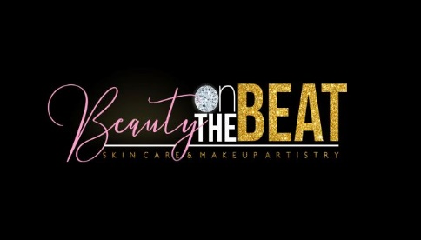

Brow Henna: Pre-Care
Pre-Treatment Instructions

- Please answer all questions on the Client Consultation Form.
- Please exfoliate the skin under and around your brows for a couple of days prior to your appointment.
- It is important for this area to be clean and free of makeup, pressed powders and moisturizers.
** The henna will not stain properly or sometimes not at all if these steps are not followed.

What is Henna
Henna is a 100% plant-derived, vegan dye that has been used for centuries on hair and skin. It is gentle on the skin and does not contain lead or ammonia. It also does not require hydrogen peroxide, so it can be safely used on anyone who is allergic to hydrogen peroxide. By tinting your brows with Henna, you can ditch your brow pencil & shadows and still flaunt fabulous looking brows that last for up to 5 weeks.

BROW HENNA AFTERCARE

- Avoid direct sunlight/sunbeds for 24 hours as this can cause the tint to fade.
- Oil-based makeup remover can cause the tint to fade faster.
- Avoid cleansing products directly on the tinted area.
- Henna tint can dissolve faster on oily skin types.
- Avoid swimming pools/saunas for 24 hours after treatment.
- Keep in mind that the tint will continue to develop following your treatment and may get a bit darker.

***For best results, treatments are recommended every 1.5 – 2.5 weeks apart as necessary**

